

Programme Name: ________**BCS HONS**_______________________________________

Course Code: __**MATH 1023**________

Course Name: ________**Additional Mathematics**___________________________

**Mathematics Open Book Examination**

Date of Submission: ______**10/4/2020**_____________

**Submitted By: Submitted To:**

Student Name**: MATH1023_Dipesh Tha Shrestha** Faculty Name**: SHANTA RAYAMJHI BASNET**

IUKL ID: **041902900028** Department**: LMS**

Semester**: Second Semester**

Intake**: September 2019**

1. A. Prove that: cotθ + tanθ = secθ cscθ

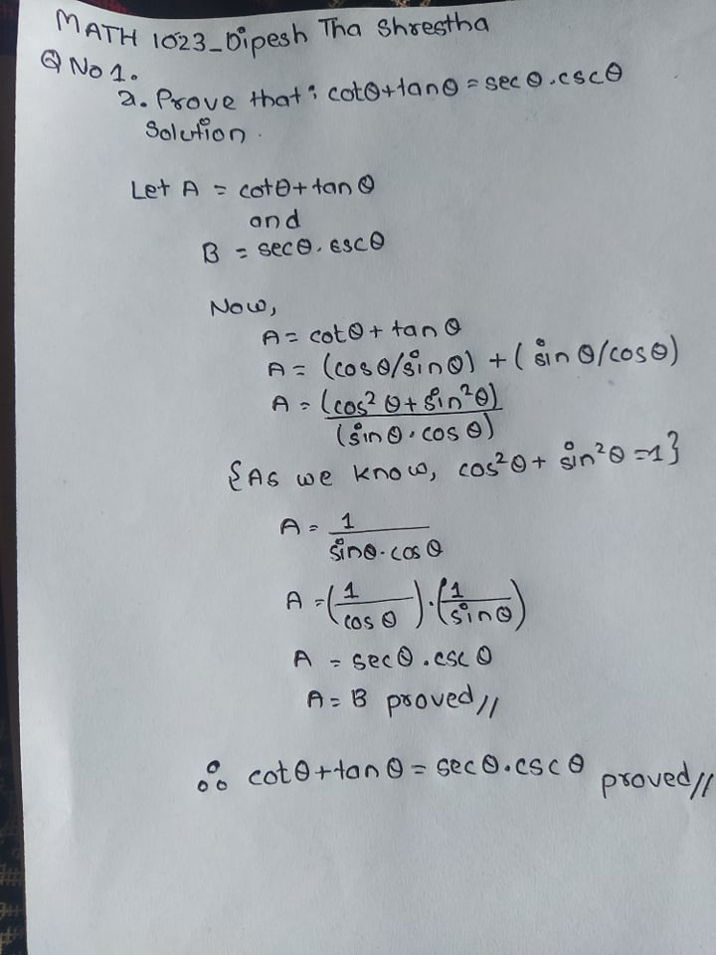

b. A boy is flying a kite .The thread is completely stretched by a strong wind it makes an angle of 600 with the ground surface .The length of the thread used between the kite and winder is 30 m. At what height from the ground is the kite flying? 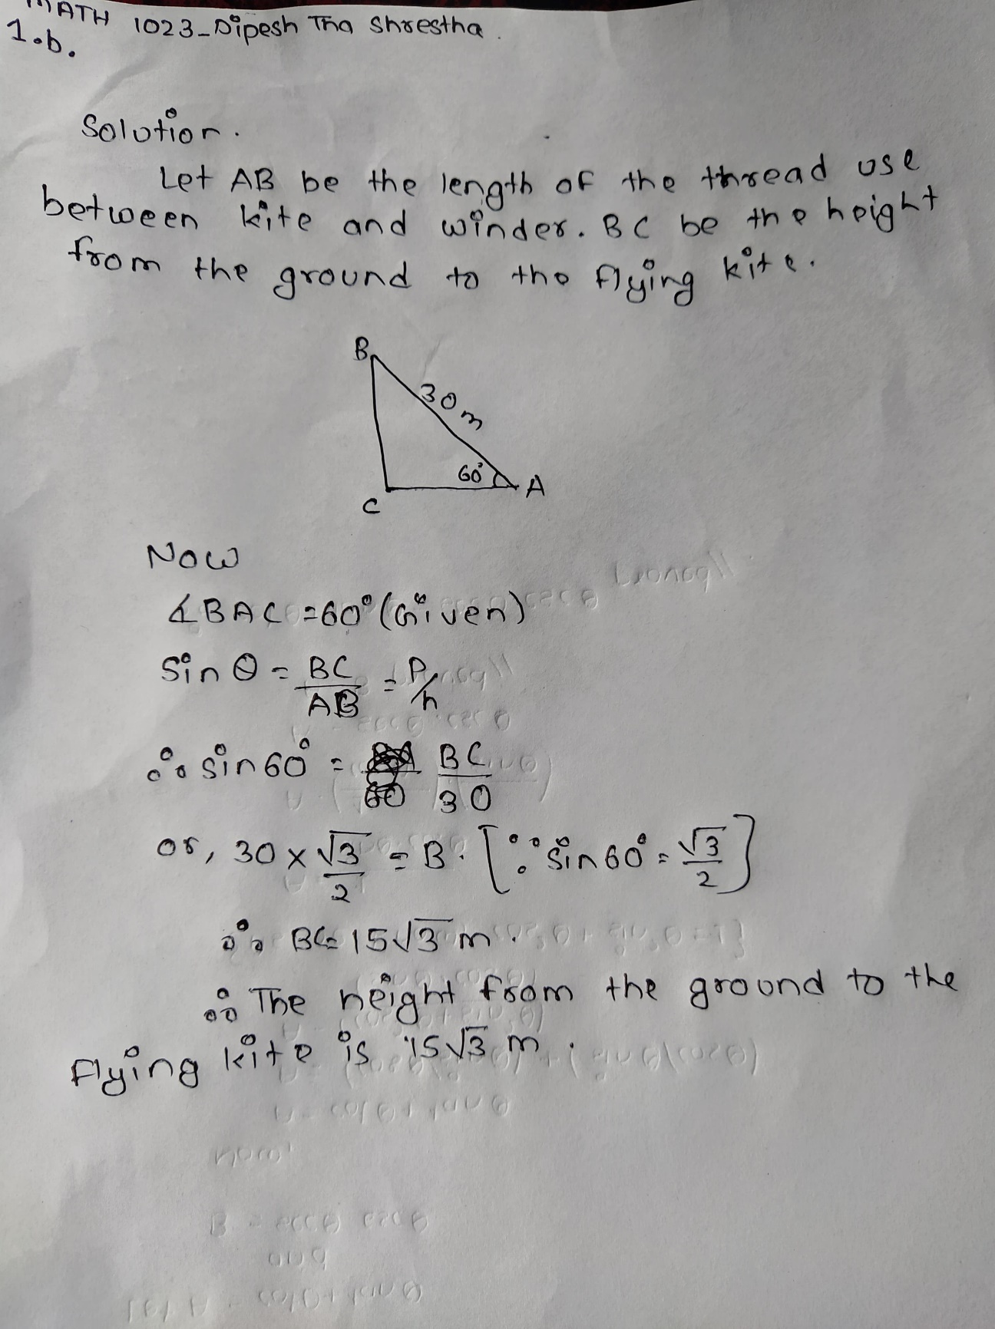

2. a. If x+2, 3x and 4x + 1 are in Arithmetic Progression then find the value of x.

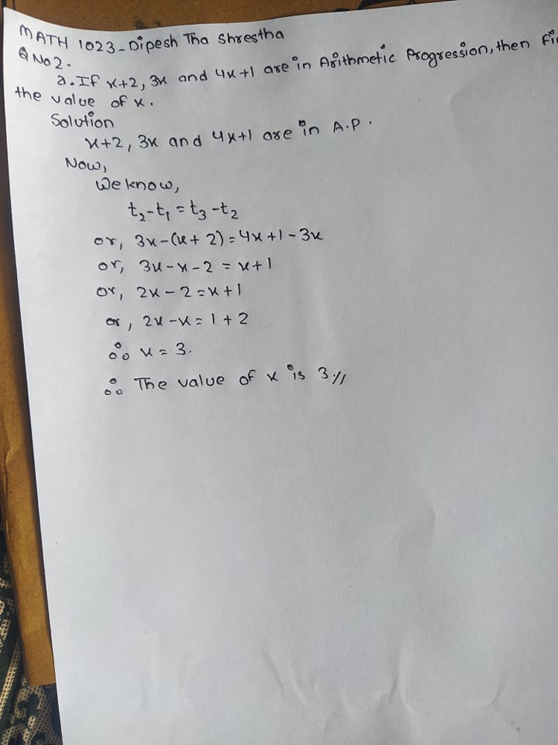

b. Find the sum of 2+ 6+18+54+ ...up to 15th term.

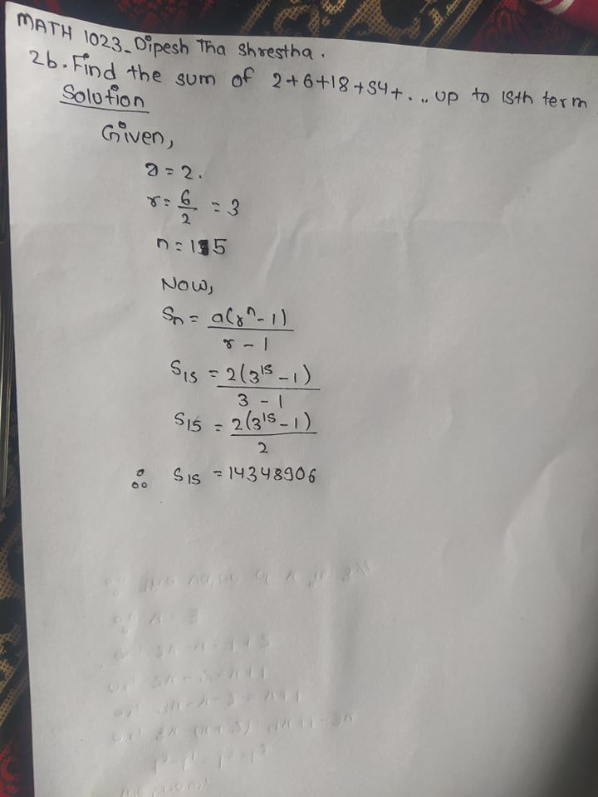

1. a. Find root of the equation using completion of square: 2x2 - 12x - 9 = 0.

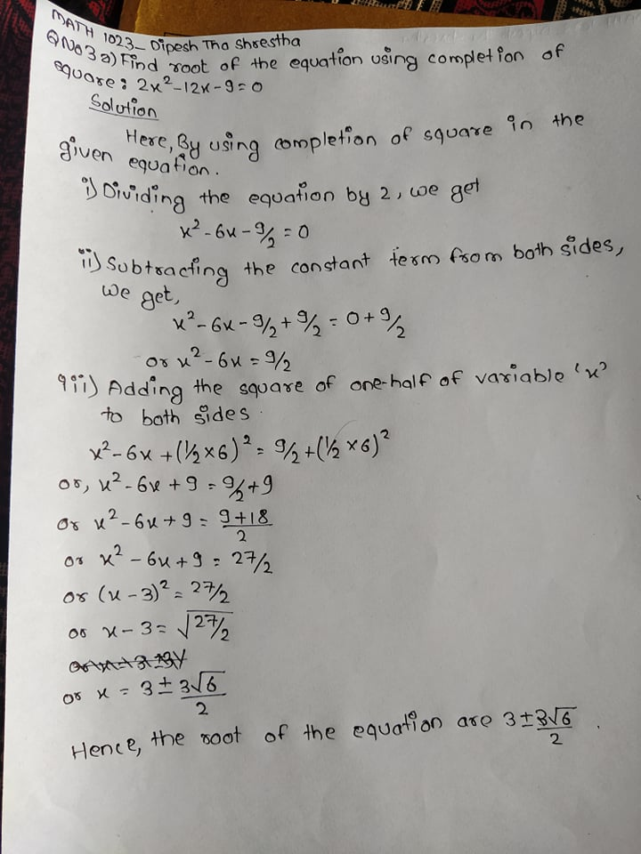

b. If α and β be the roots of x2 + px + q = 0, find the quadratic equation whose roots are α/β and β/α.

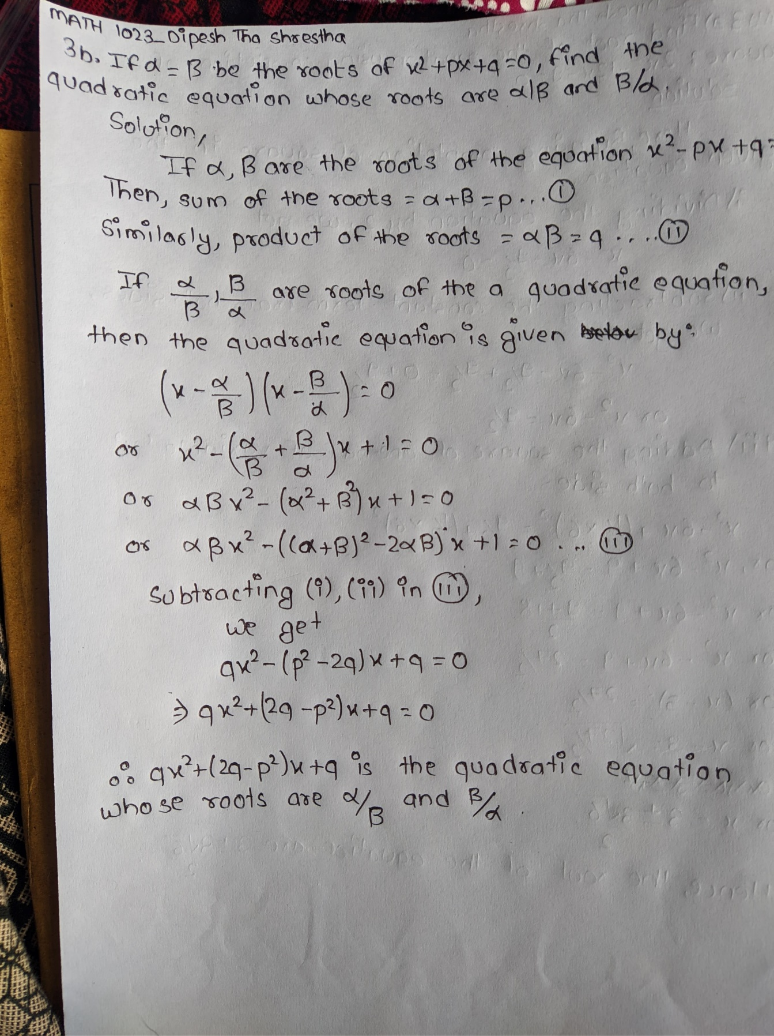

4. a. Find the derivative of tanx using first principle

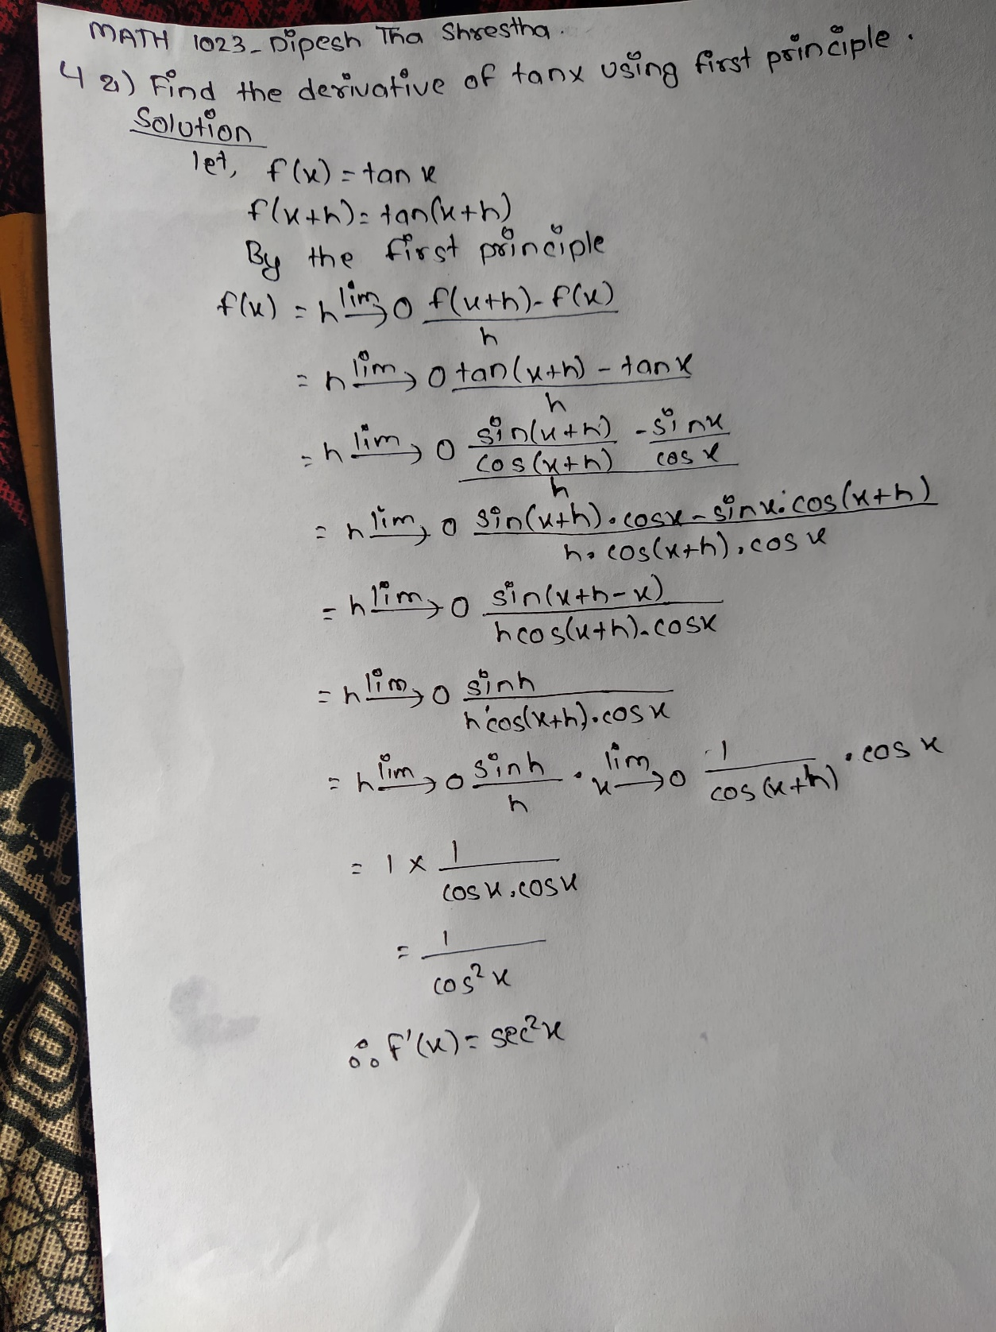

b. Find the maximum and the minimum values, if any, without using derivatives of the following functions: f (x) = 4x2 – 4x + 4.

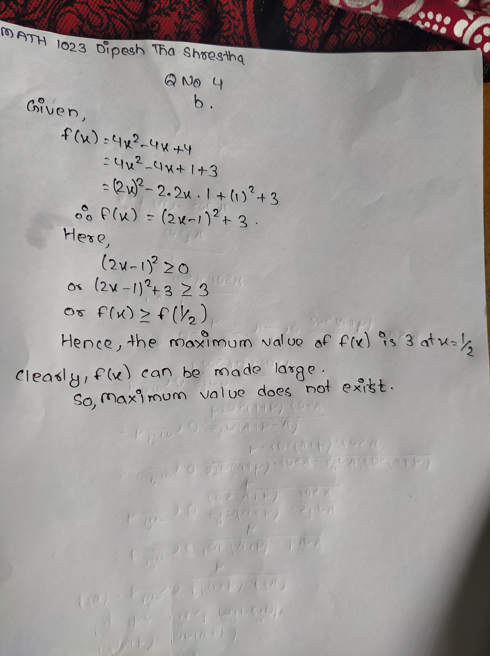

Section B

**A**

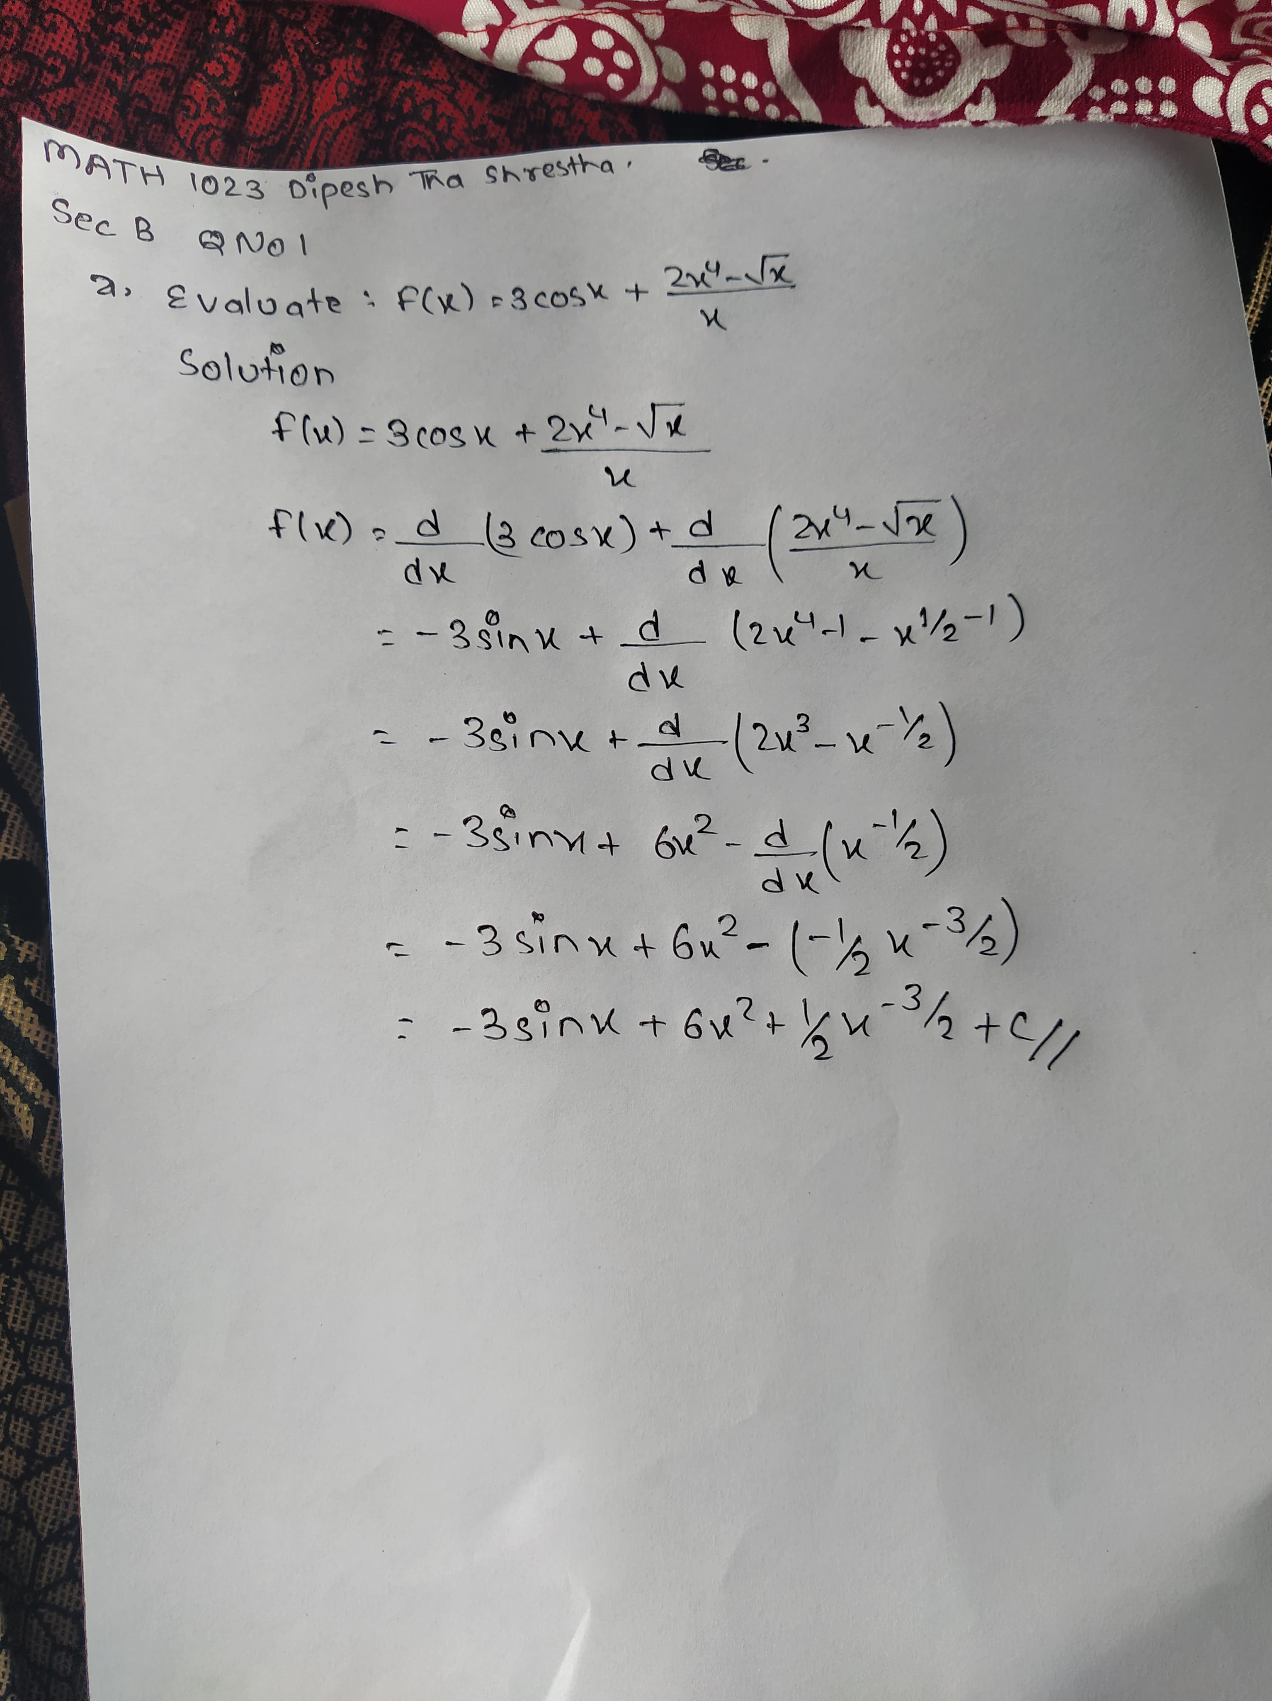

**B**

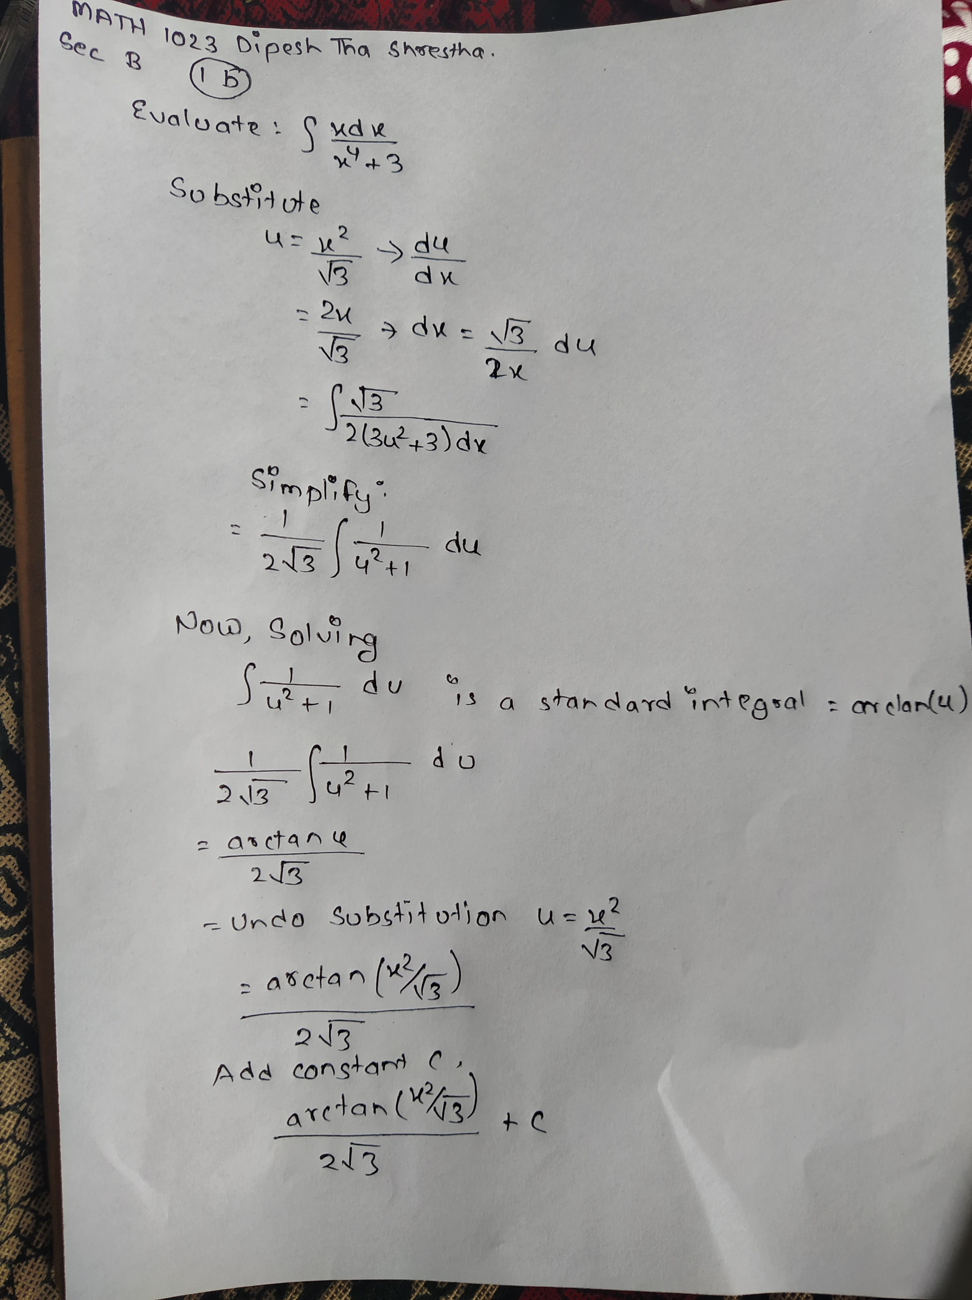

c. Find the area between f(x)=-x 2+4x and g(x)= x2 -6x+5 over the interval 0 ≤ 𝑥 ≤ 1

